DATA ANALYSIS INTERNSHIP – DAY 27 REPORT
Organization: Top Tech Developers
Topic Covered: Student Study Habits and Performance Dashboard Creation using Power BI

Introduction
Microsoft Power BI is a powerful business intelligence and data visualization tool used to transform raw data into meaningful insights through interactive dashboards and reports.
On Day 27 of the internship, a Student Study Habits and Performance Dashboard was created to analyze the relationship between students' study habits and academic performance. A new calculated column called StudyCategory was created using the Conditional Column feature in Power BI. Various visualizations were then developed using this output column to understand study patterns, grade distribution, subject performance, and gender-based analysis.

1. Objective
The main objective of this dashboard was:
- To analyze student study habits based on weekly self-study hours
- To categorize students into different study groups
- To compare study patterns with academic performance
- To create meaningful visualizations for educational analysis

2. Data Preparation
A new column named StudyCategory was created using the Conditional Column option in Power BI.
Conditions Used
Weekly Self Study Hours | StudyCategory
Less than 20 Hours | Low Study
Greater than or Equal to 25 Hours | Medium Study
Else | High Study
Purpose
- Groups students based on study behavior
- Simplifies performance analysis
- Helps identify study patterns among students
Observation
The newly created StudyCategory column became the foundation for all dashboard visualizations and analysis.

3. Dashboard Visualizations
Different visualizations were created using the StudyCategory column.

1. Pie Chart – Count of Students by StudyCategory
Purpose
Displays the distribution of students across:
- Low Study
- Medium Study
- High Study
Insight
- Most students belong to the Low Study category
- Fewer students fall under the High Study category
- Helps understand overall study behavior distribution
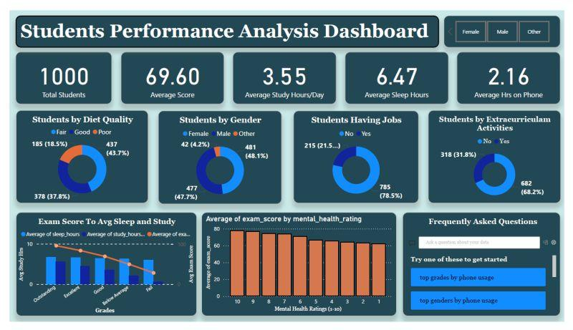
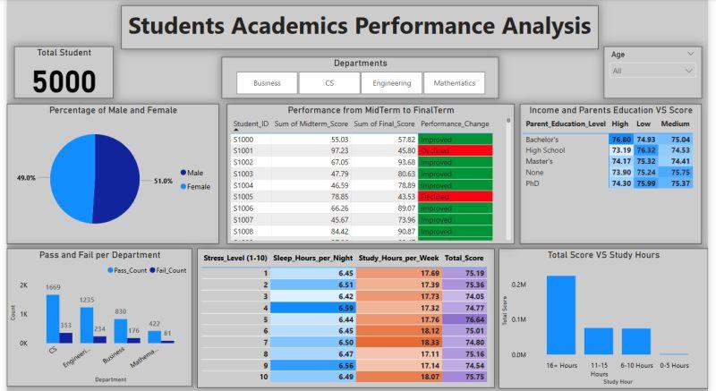
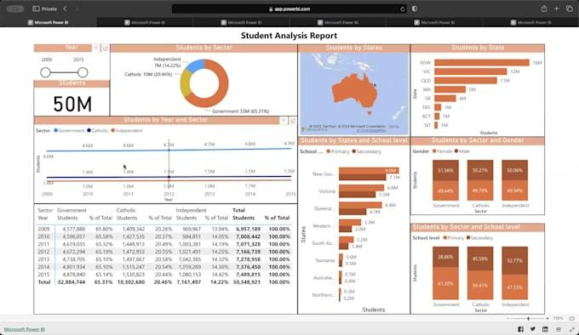

2. Clustered Bar Chart – Count of StudyCategory by Grade
Purpose
Compares student study categories with academic grades.
Grades Included
- Excellent
- Good
- Average
Insight
- Students with Good grades form the largest group
- Grade distribution varies across study categories
- Helps evaluate academic performance trends

3. Funnel Chart – Count of Students by StudyCategory
Purpose
Represents the number of students within each study category using a funnel structure.
Insight
- Low Study category contains the highest number of students
- Medium Study category follows next
- High Study category has the smallest student count
Observation
The funnel chart provides a clear comparison of student distribution.

4. Donut Chart – Sum of History Score by StudyCategory
Purpose
Compares total History subject scores among different study groups.
Insight
- Low Study and Medium Study categories contribute a larger portion of total History scores
- Student population size influences overall score contribution
Observation
The chart helps analyze subject performance across study patterns.




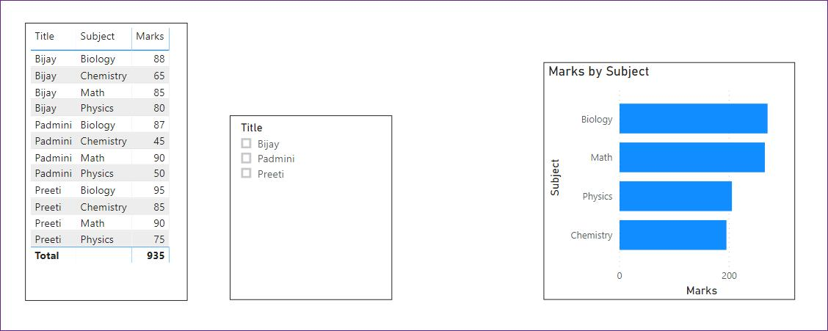
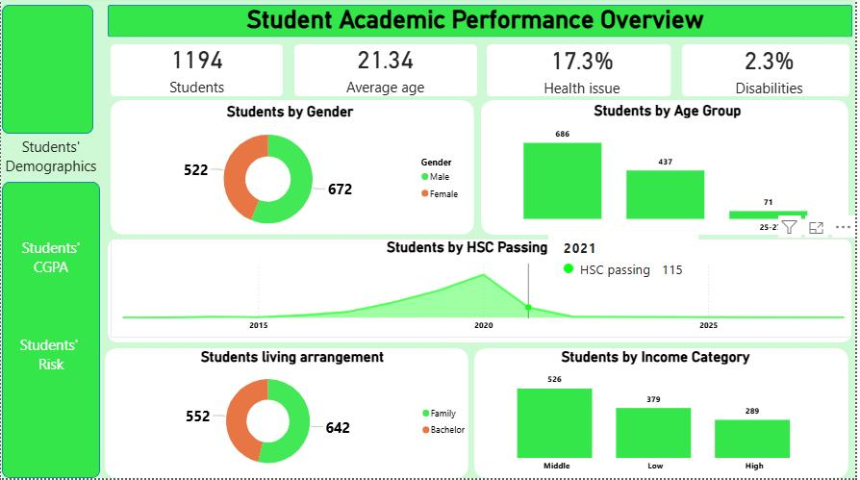

5. Area Chart – Sum of Weekly Self Study Hours by StudyCategory
Purpose
Displays cumulative study hours for each study category.
Insight
- Medium Study category recorded the highest total study hours
- Study habits can be compared visually
- Highlights overall learning effort among students
Observation
Area charts help understand accumulated study contributions.

6. Stacked Area Chart – Count of Grade by StudyCategory and Gender
Purpose
Analyzes grade distribution across study categories based on gender.
Categories Analyzed
- Male Students
- Female Students
Insight
- Both genders are represented across all study categories
- Allows comparison of study behavior patterns
- Supports gender-based educational analysis
Observation
The visualization helps identify similarities and differences between male and female students.


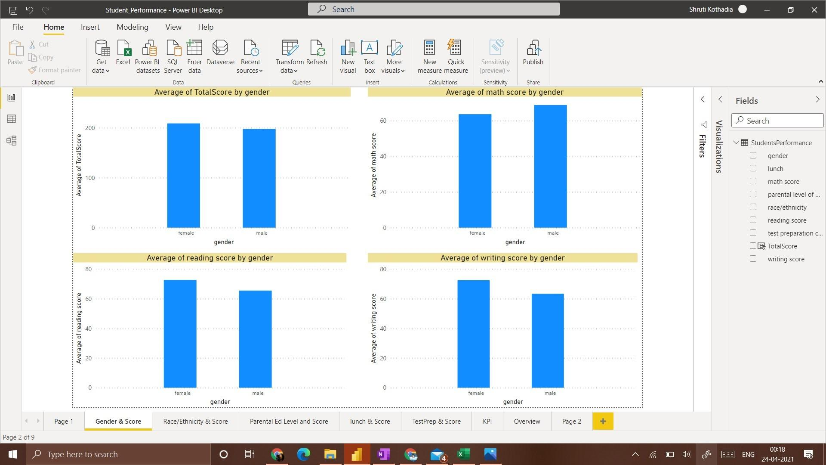

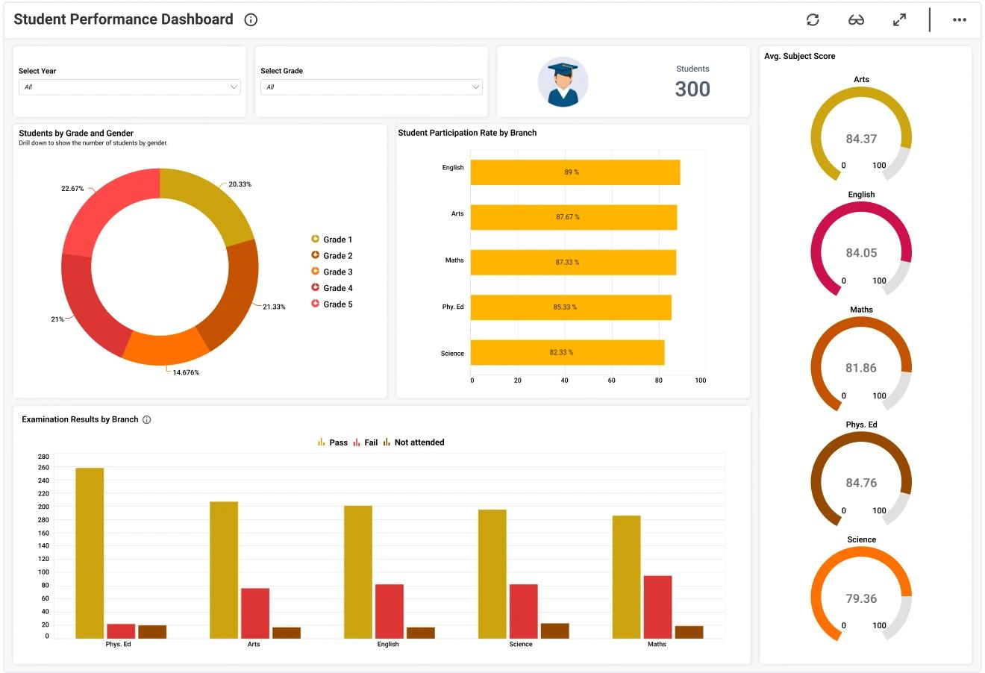

4. Overall Dashboard Analysis
The dashboard successfully analyzed:
- Student study habits
- Grade performance
- Subject score contribution
- Gender distribution
- Weekly self-study behavior
Key Findings
- Most students belonged to the Low Study category
- Good grade students formed the largest academic group
- Medium Study students accumulated the highest study hours
- Both male and female students were represented across all study categories
- StudyCategory helped simplify educational performance analysis

Tools Used
- Microsoft Power BI
- Conditional Column Feature
- Data Transformation
- Dashboard Design
- Data Visualization

Visualizations Used
- Pie Chart
- Clustered Bar Chart
- Funnel Chart
- Donut Chart
- Area Chart
- Stacked Area Chart

Learning Outcome
On Day 27, I learned how to create calculated columns using Conditional Column logic in Power BI and use them for dashboard development.
I understood:
- how to create output categories using conditions
- how to analyze student study habits
- how to compare grades and study patterns
- how to create educational dashboards using Power BI
- how visualizations improve data interpretation and decision-making

Conclusion
The Day 27 internship session helped me understand the practical application of Conditional Columns and dashboard creation using Microsoft Power BI.
A new output column named StudyCategory was successfully created and used to develop multiple visualizations including Pie Chart, Clustered Bar Chart, Funnel Chart, Donut Chart, Area Chart, and Stacked Area Chart. The dashboard provided valuable insights into student study behavior, academic performance, subject-wise contribution, and gender-based analysis. This activity enhanced my skills in data transformation, visualization, and educational analytics using Power BI.

